**Class Diagram**

**• Entity Class Diagram**

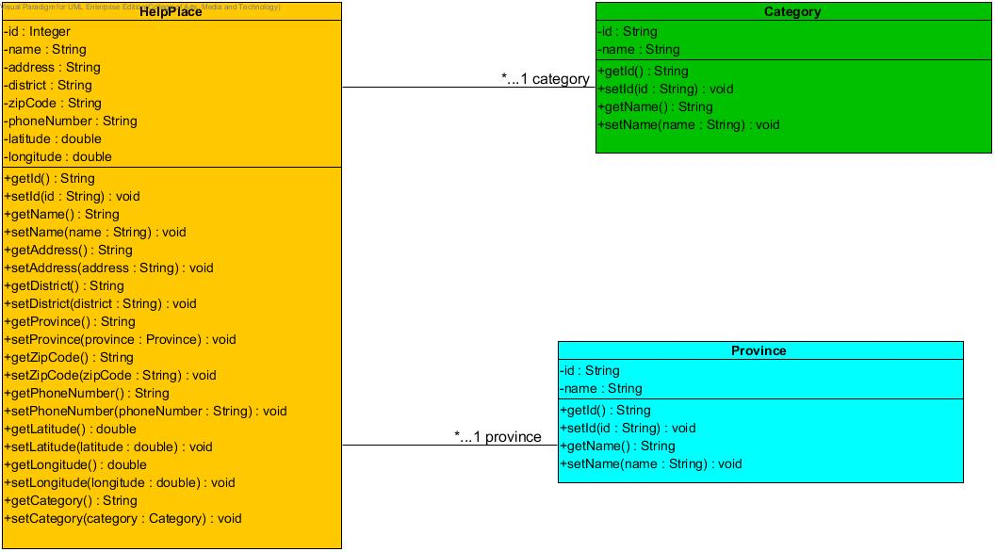

**• Controller Class Diagram**

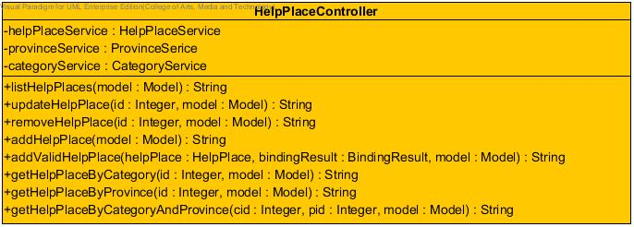

**• DAO Class Diagram**

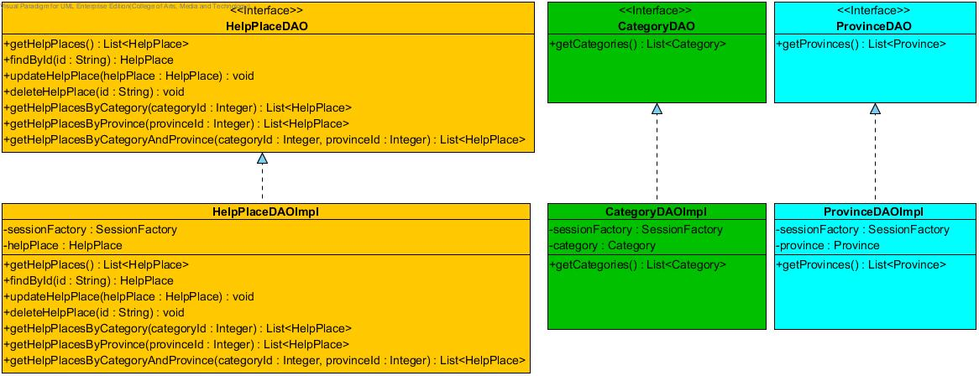

**• Service Class Diagram**

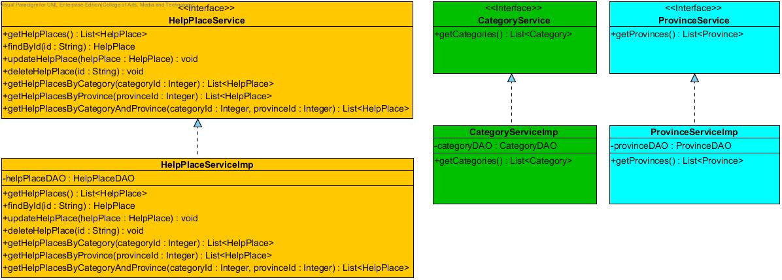

**• Emergency Information on Mobile Class Diagram**

